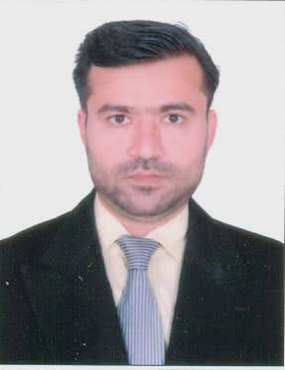

(Page 1of 3)

RAIS KHAN

E-mail: raiskhannbp@yahoo.com
Phone: 0345-2456247, 03363574051
H/NO 1725/4031, Guldad Shah Road, Madina Colony,
Behind Baldia Primary School, Baldia Town # 5,
Karachi-75760 Pakistan

CAREER OBJECTIVES

To get the challenging position in the field of Accounting/Business in a professional and team-oriented environment that will help me to utilize my skills with career growth. To join an organization that will groom my skills and capabilities and help me in getting a responsible position in middle management cadre in a satisfactory and comfortable working environment.

PROFESSIONAL EXPERIENCE

Benazir Income Support Program.

Worked in DMS, as
(Data Entry operator)
Since Jan. 2011 TO July 2011.

UNITED BANK LTD.

Worked in UBL (Hub Chowki Branch) as
(Cash officer/Universal Teller)
Since April 2008. TO May 2009.

NATIONAL BANK OF PAKISTAN

Worked in NBP (Hub River Road Branch) as
(Cash officer/Customer service officer)
Since January 2007. TO April 2008.

PROCON ENGINEERING (PVT) LTD

Six Years Experience as “Store Incharge/Computer Operator”
In Procon Engineering (Pvt) Ltd.

ABID INDUSTRIES (PVT) LTD

Two Years Experience as “Store Incharge/Computer Operator”
In Abid Industries (Pvt) Ltd.

RASHEED INDUSTRIES (PVT) LTD

Two Years Experience as “Store Incharge/Computer Operator”
In Rasheed Industries (Pvt) Ltd.

(Page 2 of 3)

ACADEMIC QUALIFICATION

2001

B.COM (Bachelor of Commerce) from University of Karachi.

1997

HSC from Board of Intermediate Education Karachi.

1994

SSC from Board of Secondary Education Karachi.

PROFESSIONAL QUALIFICATION

8 Six Months Certificate in Advance MS. Office from Paragon Computer Institute.

8 Well experience in Dos, Windows, MS-Office, Internet, etc.

8 English Type-writing Certificate With 45WPM from Sindh Board of Technical.

8 English Language Certificate Course from Pakistan American Cultural Center (PACC) 1998.

MAJOR DEVELOPMENTS DETAIL

❑ General Ledger (Accounts Software)

✓ Provide Balance Sheet
✓ Income Statement
✓ Ledger for each Account Head
✓ Voucher wise Reports

(Page 3 of 3)

PERSONAL

Name : Rais Khan
Father’s Name : Wareed Khan
Date of Birth : 2nd May, 1978.
NIC # : 42401-1836782-3
Religion : Islam
Domicile : Sindh
Nationality : Pakistani
Mailing Address : H/NO 1725/4031 Guldad Shah Road, Madina Colony,
Behind Baldia Primary School Baldia Town # 5,
Karachi, 75760 Pakistan

.

  Languages: Speak, Write & Read

- English
- Urdu
- Pushto

